**COE-C3005 Finite Element and Finite Difference Methods**

**Modelling assignment 2021**

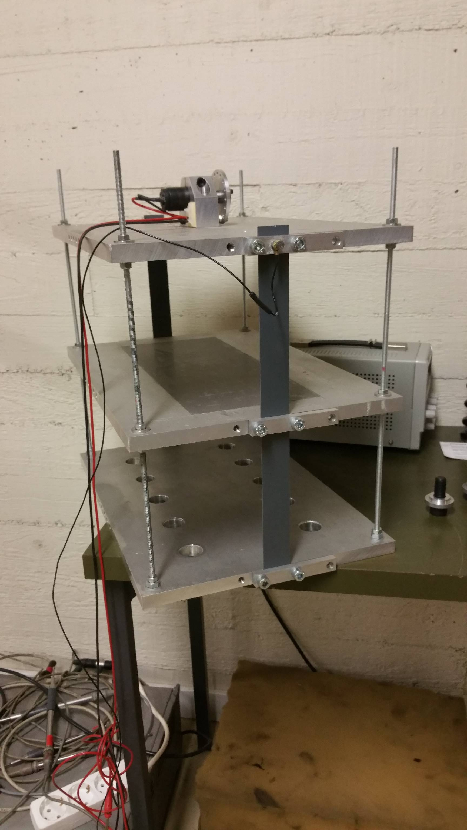

Figure 1. Set-up of the three-floor building experiment

In the modelling assignment, the dynamic properties of three-floor building in Figure 1 obtained by a model are compared with experimental results. The measures of comparison are the two lowest frequencies of the free vibrations. The calculations with the model use discretization by (1) particle surrogate method, (2) finite difference method, and (3) finite element method. Reporting consists of this assignment paper supplemented by the outcome of calculations (the missing data in Table 2). Return your report (in PDF) on Sun 25.04.2021 23:55 at the latest (MyCourses).

**Structure idealization**

The structure idealization is shown in Figure 2 and the values of the geometric and material parameters therein in Table 1. Floors are made of aluminum and columns are threaded bars of standard steel. Displacement is constrained by flexible strips of plastics.

*lY*

*lX*

Threaded bar M6of steel

B

A

*Z*

*Z*

Plastic stripof thickness *s*

*w*

*h*

*t*

Aluminium

floor

*d*

*h*

*Y*

*W*

*L*

*X*

Figure 2. Structure idealization.

Table 1. Geometrical and material parameters of the structure.

|  |  |
| --- | --- |
| geometry | value |
| *d* | 0.0048 m |
| *h* | 0.156 m |
|  | 0.4 m |
|  | 0.243 m |
| *L* | 0.44 m |
| *W* | 0.295 m |
| *t* | 0.015 m |
| *w* | 0.04 m |
| *s* | 0.002 m |

|  |  |
| --- | --- |
| material | value |
| Standard steel | |
|  | 210 GPa |
|  | 0.30 |
| Aluminium | |
|  | 70 GPa |
|  | 0.33 |
| PVC | |
|  | 2 GPa |
|  | 0.4 |

**Experimental frequencies**

In vibration experiment, the top floor is hit to start vibration. Accelerometer, connected to a laptop computer through an amplifier and a signal processing unit, is used to measure acceleration of one point of the top floor as the function of time. Measurement is repeated 6 times to get picture about the effect of random factors like location of the hit (is not a controlled variable in the experiment design).

Figure 3. Time-acceleration and frequency-amplitude representations of the time-series.

In processing of data, the time-acceleration representation is transformed to frequency-amplitude representation by using Discrete Fourier Analysis. The peaks in the amplitudes indicate the eigenfrequencies of free vibrations.

**Modelled frequencies**

In the simplified continuum model, structure moves in plane, floors are considered as rigid bodies, columns are modelled as beams, and plastic strips are omitted. Then, the simplest approximate solution methods according to the Particle Surrogate Method, Finite Difference Method, and Finite Element Method:

PSM: 

FDM: ,

FEM: ,

contain only the horizontal displacements of the floors as the unknowns. To find the modelled frequencies and the corresponding modes, use modal analysis with the solution trial

 ,

where  and . Scale the modes for unit lengths ().

Table 2. Experimental and modelled values for the first two frequencies and modes of free vibrations.

|  |  |  |  |  |  |  |
| --- | --- | --- | --- | --- | --- | --- |
| method |  |  |  |  |  |  |
| EXP |  |  |  |  |  |  |
| PSM |  |  |  |  |  |  |
| FDM |  |  |  |  |  |  |
| FEM |  |  |  |  |  |  |